**INDIA’S AGRICULTURAL CROP PRODUCTION ANALYSIS (1997-2021)**

**INTRODUCTION**

* 1. **OVERVIEW**

India is a global agricultural power house, it is world’s largest producer of milk, pulses and spices. It is second largest producer rice, wheat, cotton, sugarcane,farmedfish, sheep,Goatmeat,fruit and vegetables and tea.

While agriculture’share in india’s economy has progressively declined less than 15% due to high growth rates. Over the last 75years. Indian agriculture has made rapid strides. From a merage 55 million tonnes ,production of foodgrains has increased to a record 308.65 million tonnes last season (july 2020-june 2021). Production of pulses, coarse cereals, natural fibres, sugarcane, vegetables and fruit have all increased manifold since independence.

* 1. **PURPOSE**

Agriculture is the foundation of the Indian economy.The population of india mostly on agriculture for their livelihood and agriculture. Contributes to 40 percent of the total GDP of the country.

Agricultural also known as farming is the process of producing food, feed, fiber and other desired products by cultivation of certain plants and the raising of domesticated animals.

Over 70 percent of the rural household depend on agriculture.The share of agriculture and allled sectors in gross value added (GVA) of india at current Prices stood at 20.2% .

Growth in agricultural output over the past three decates has been strong and importantly crop production able to broadly keep pace with the demands from a growing population. The government is also gradually improving access to insurance through the national insurance scheme , although in 2009 only 18 million farmers were insured under the scheme.

In certain areas , farmers growing these crops and accessing seasonal agricultural operations loans from financial institution are required to purchase this insurance , while others can opt in voluntarily.

**2. PROBLEM DEFINITION & DESIGN THINKING**

**2.1 EMPATHY MAP**

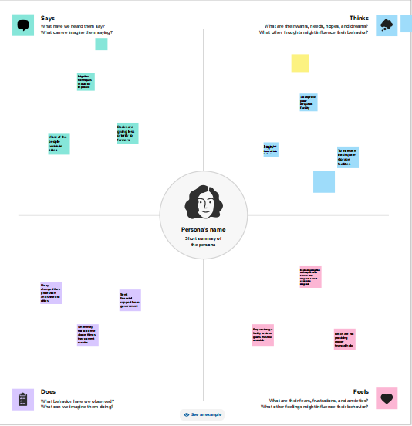

**2.2 IDEATION & BRAINSTROMING MAP**

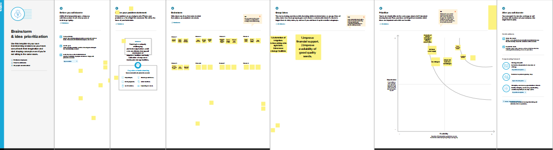

**3. RESULT**

**3.2 AREA VS PRODUCTION**

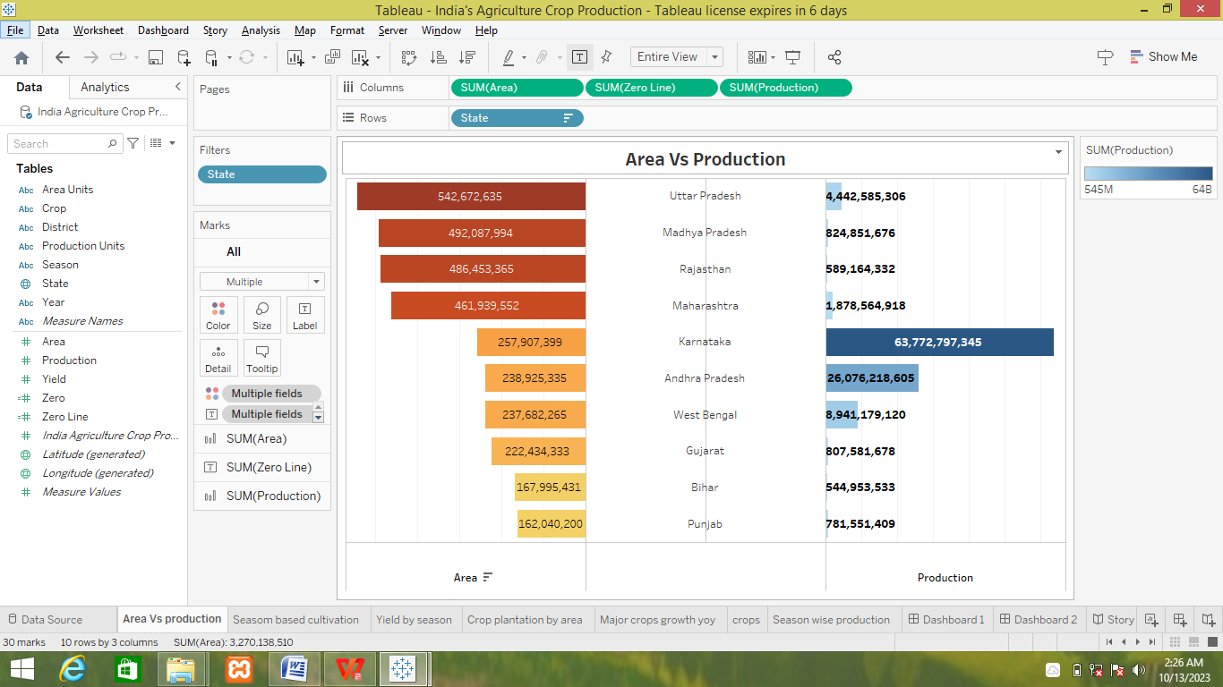

**3.3 SEASON BASED CULTIVATION AREA**

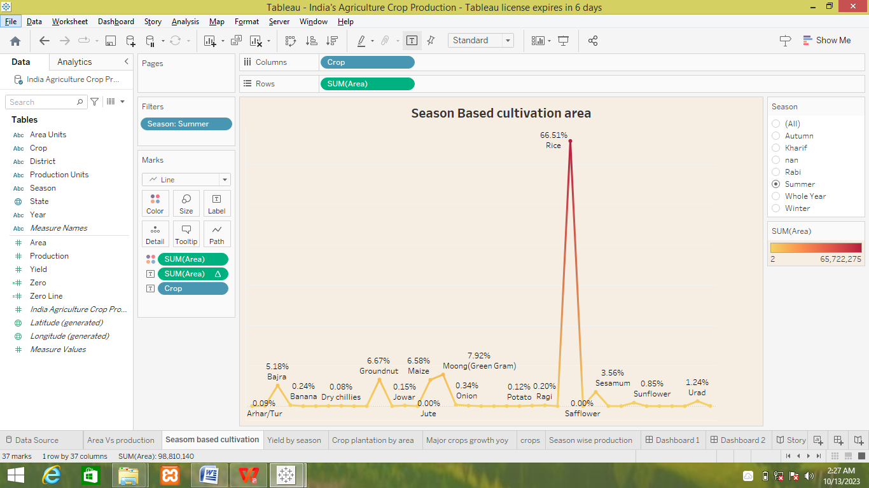

**3.4 YIELD BY SEASON**

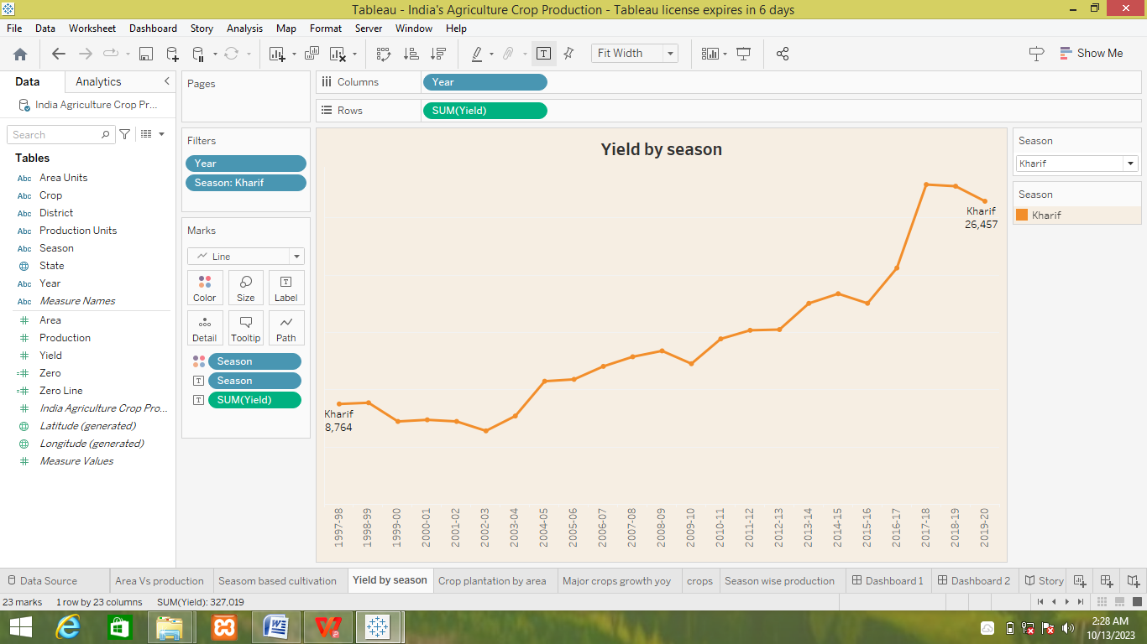

**3.5 CROP PLANTATION BY AREA**

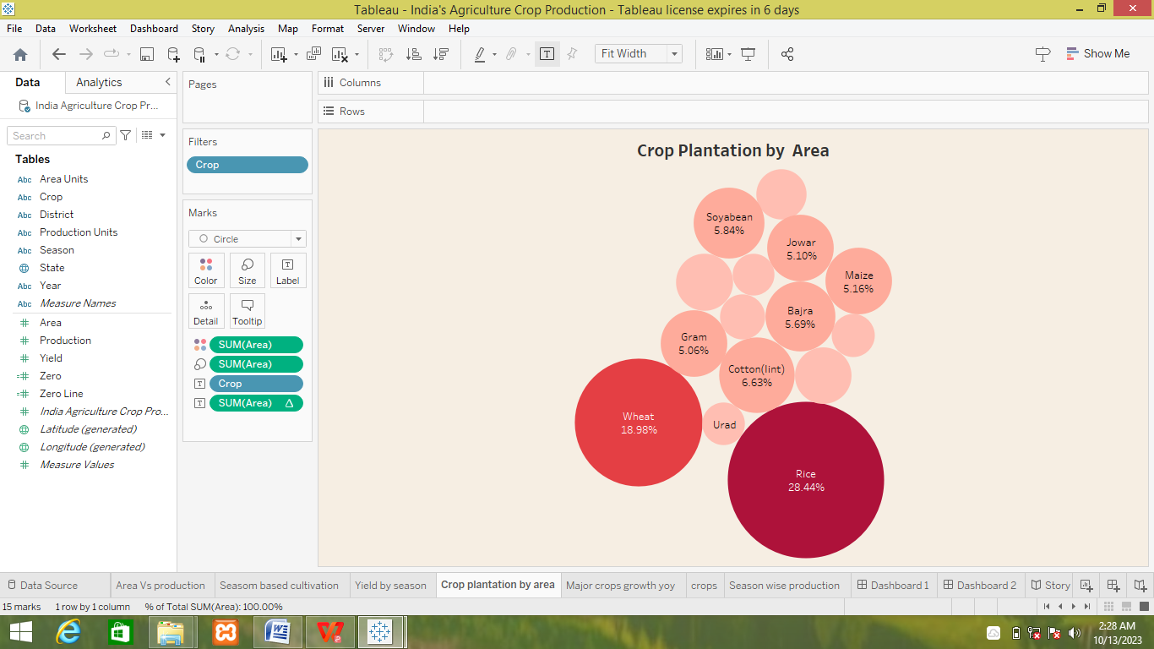

**3.6 MAJOR CROPS**

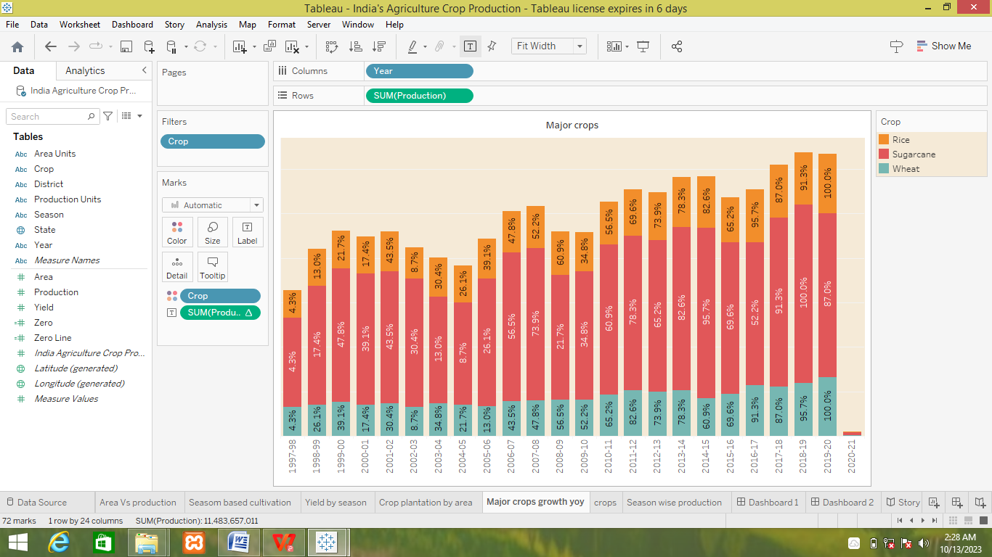

**3.7 CROPS**

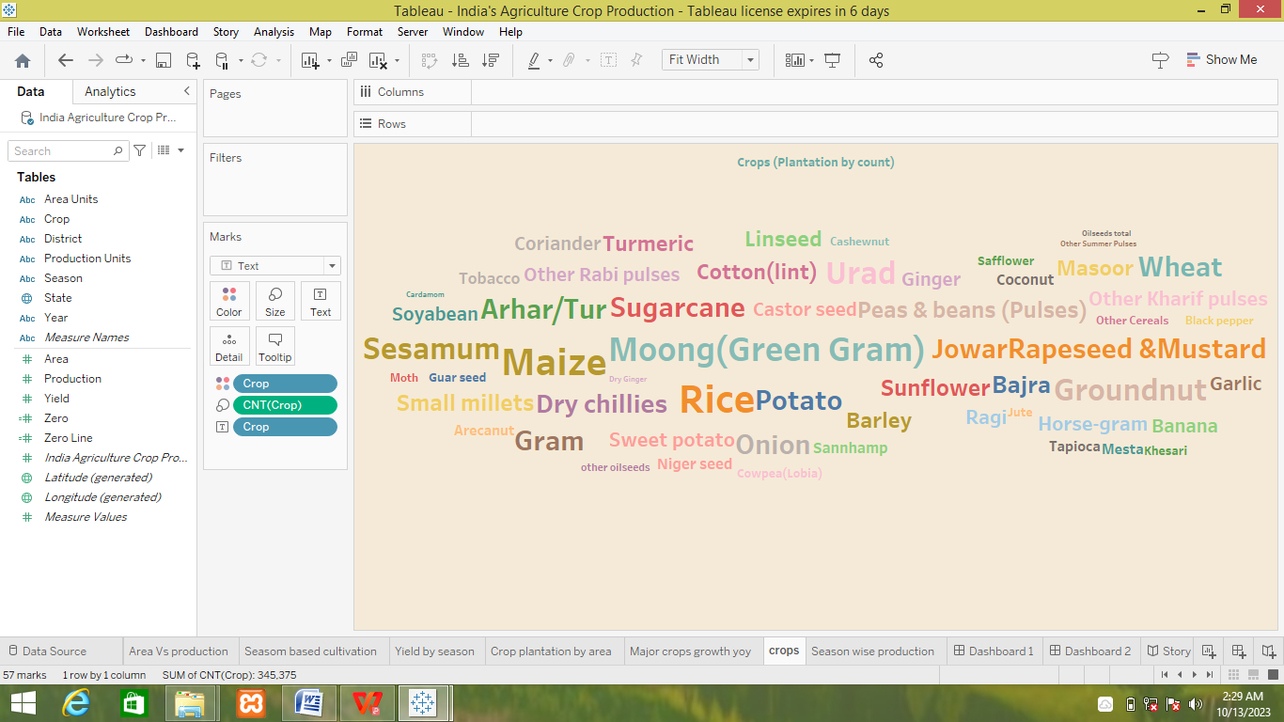

**3.8 SEASON WISE PRODUCTION**

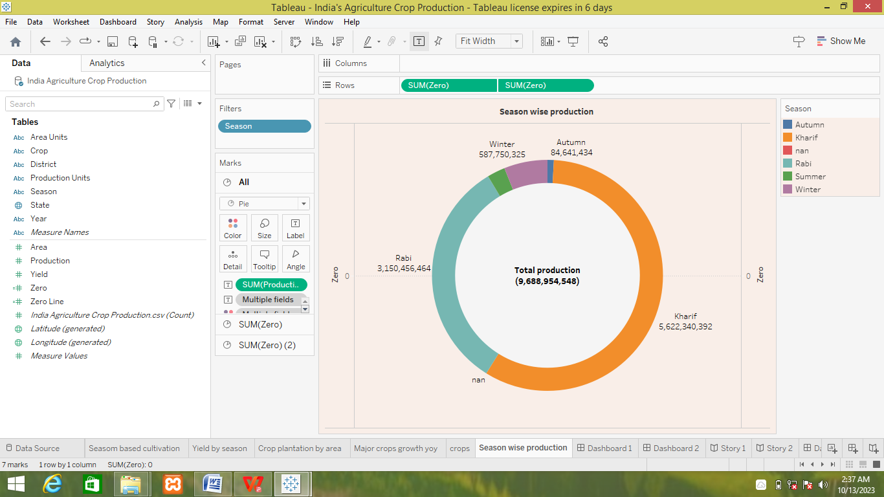

**3.9 DASHBOARD : 1**

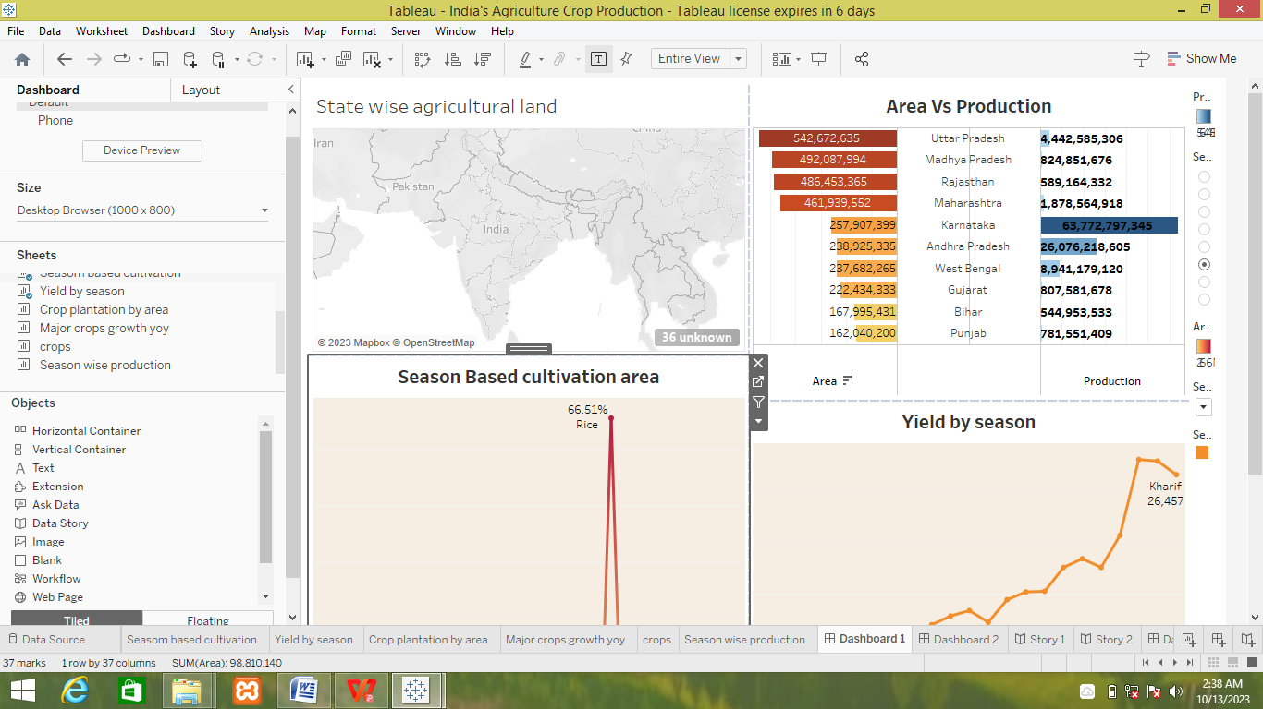

**3.10 DASHBOARD : 2**

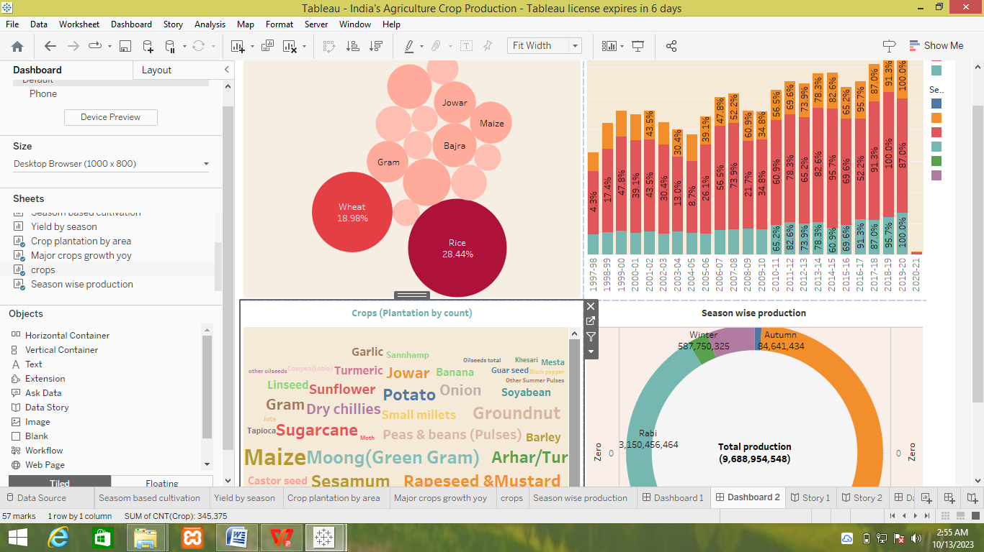

**3.11 STORY : 1**

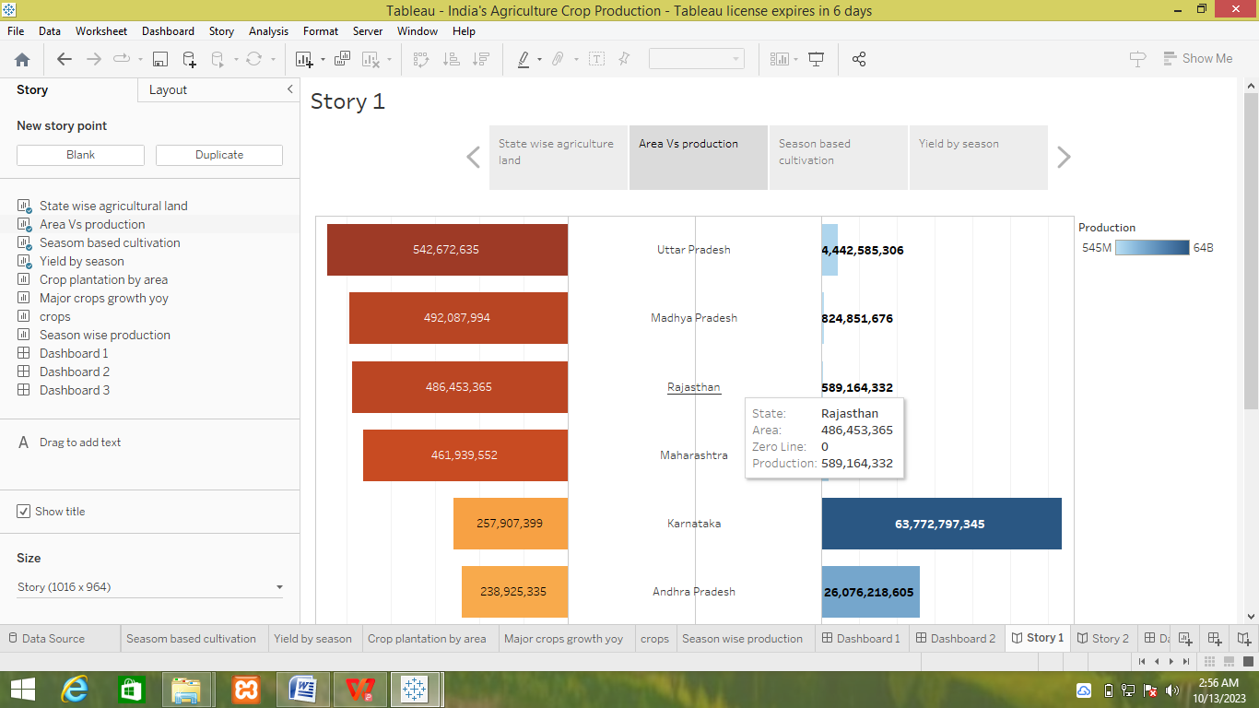

**3.12 STORY : 2**

**INSIGHTS INTO INDIA’S AGRICULTURAL CULTIVATION**

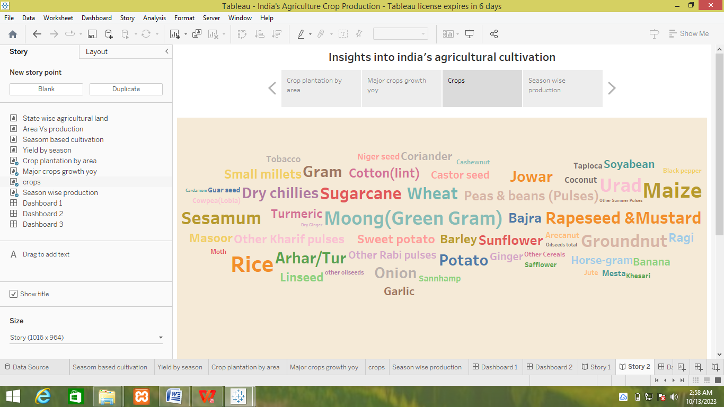

**4. ADVANTAGES**

* Better use of land more profitable to grow crops on land best suited to it.

Example; jute growing or cultivation on swapy land in west bengal. Less equipment and labour.

* The efficiency and skill of the labour increased specialization allows a man to more

efficient and expert at doing a few things.

* Intensity of production leads to relatively large amount of output. A wheat harvester there can be maintained in a highly specialized wheat form.
* Organic farming usually goes down in a natural environment. Unnecessary enclosures are not used for crops or plants.
* Unlike other forms of farming organic farming does not involve any articifical sources like chemicals to drive away pests or to speed up process of farming.The chemicals are used in commercial and farming method.
* Organic farming does not use any form of chemical nor does any form of pollution

happen because of it.

**DISADVANTAGES**

* There is greater risk . when failure of crop and decreasing market price of the product demand in market of product.
* It is not possible to maintain soilfertility lack of crop rotation. Irregular income of the form as they get income only once or twice in a year.
* By product of crop are not property utilized as numbers of livestock’s are less in number.Does not help in suppling all the food needs of the familymembers of the farmers.
* Organic farming has to executed well which needs a lot of time and not to forget

weed-prevention.

* The seeds of asssGMO plants once planted create GMO crops. This crops produce seeds

and the pattern continues.This makes very difficult to tell from the organic and GMO crops.

**5. APPLICATIONS**

* Based on understanding,plants, soil, wheather and management interactions.
* The country experiences all 15 prominent climates. It cultivates 50% of it total geographical area placing it among top land

uses for agriculture.

* The sector employs 49.6% of the work force which is often seasonal under

employed and under paid and accounts 17% of india’s GDP.

* The country total food grain production was estimated to be record

high 314.6 million tonnes over 2010-21.

* Predict crop growth , yield , timing. Optimize irrigation management.The production of cereals and pulses has increased at CAGR of 2.0% and

1.8% respectively from 2017-18 to 2021.

* In the post-green revolution era , the new agricultural strategies research and technology was mostly limited to producing specific food grains , wheat and rice.
* In some agriculturally backward areas with no irrigation system and access to fewer resources , dryland farming has been introduced.
* To support the development in those areas various modern techniques has been installed in the backward areas.

**6. CONCLUSION**

Agriculture is an important sector of the country. The new changes over the last few

years have been enormously helpful to contribute more towords economic growth.

The future of Indian agriculture seems bright and promising with the advent of new

technologies. The government has increased it focus on the sector implementing

various policies and initiatives to boost productivity and growth. India’s vast and

diverse agricultural landscape , coupled with advancements in technology , provides

immense opportunities for farmers to harness their potential and increase yield.

Inceasing population , increasing average income and globalisation effect in

India will increase demand for quantity , quality and nutritious food and variety food.

Efforts are being made to convert all the challenges in agriculture into opportunities

and this process is the future of agriculture. But if the past and present are a clue to the

future , Indian growers will continue to seek better ways to produce crops by embracing

innovation.

**7. FUTURE SCOPE**

India’s agriculture sector plays a critical role in the country’s bioethanol

sector as well as supporting moves towards food security , energy security and

decarbonization goals.

The country has come a long way with bioethanol policies and it is likely to

achieve a 10% ethanol. There will be pressure on agriculture to meet future

targets , so innovation will be important.

Participating in biofuel will provide farmers with an opportunity to improve

economic efficiency. It will also create competition between food and fuel

producers for valuable crops.

The Indian agricultural sector has been great success story over the past

60 years. After years of import dependency punctuated by severe droughts in

the mid 1960s , a series of policy initiatives and technology shift boosted

agriculture production and made india self sufficient in areas such as wheat ,

rice , suger and animal proteins.